InfoReady Review™: User Authentication
Single Sign On (SSO) systems enable large enterprises like universities to support user access to multiple software systems through one username and password. While InfoReady Review™ includes its own authentication mechanism, InfoReady will integrate Review with your SSO system for an additional fee.

If you choose the SSO Integration option, InfoReady Review will be integrated with your SSO system so that university users can log in using university credentials, and each time the user logs in we can confirm that the user remains authorized by the university to access Review.

Creating Accounts and Logging in without SSO Integration
InfoReady Review comes with its own unique authentication mechanism, which is ready to use “out of the box.” Under the Configure System section of Administration, you can enter email domain addresses that your InfoReady Review site should recognize for the purposes of account creation. Users who try to create an account in Review with an unrecognized email domain will be unable to create an account. Users with email addresses using a Recognized Email Domain will be able to create accounts, and will have a confirmation email sent to their email address.

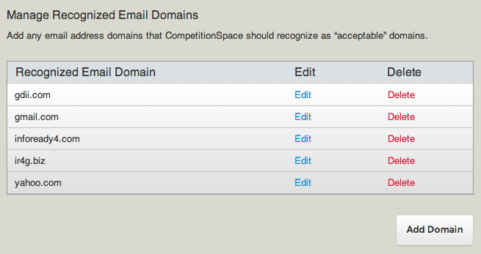
Figure: Manage Recognized Email Domains section of Configure System

When a user clicks the “Register” link in the upper right hand corner of the InfoReady Review interface, a form like the one below will load. To create an account, the user must provide an email address that uses a Recognized Email Domain, create a password, and fill out the ReCaptcha form (this helps stop bots from trying to create fake accounts). If the email address used aligns with a Recognized Email Domain, the user will get an email confirming the account. There will be a link in the email that the user can click on to confirm the account, and they can start applying to competitions.

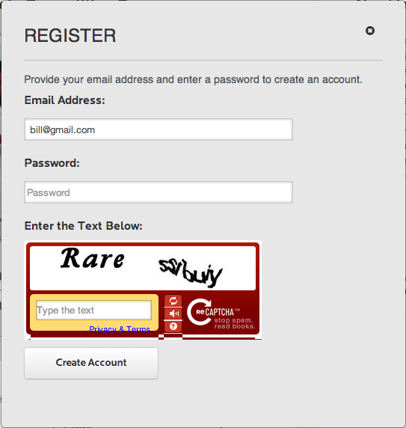
Figure: The Review Registration Form

Creating Accounts and Logging in with SSO Integration
With an SSO integration, authentication works a bit differently. The option to create an account in the way described above is still there, but the Login form focuses on the university’s SSO system instead. You can see this illustrated in the image below.

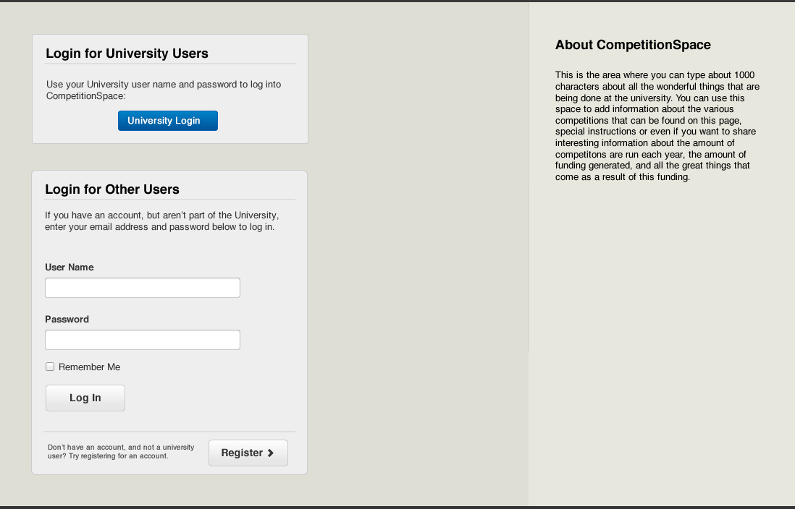
Figure: The Login Page for SSO integrated Review sites.

The “Login for University Users” option will invoke the university’s SSO system, and take the user to the appropriate login form for that system. After the user is authenticated by the university’s SSO system, he will be taken back to InfoReady Review logged into his account. If the user does not have an InfoReady Review account at that time, one will be created for him after successfully authenticating through your SSO system.

The “Login for Other Users” option provides the standard InfoReady Review login and registration options. Why are both options offered? In most cases, Review customers make some competitions available to non-university users, and application reviewers are sometimes non-university users.

SSO Integration: The Integration Process
The first step is determining that you want to integrate your SSO system with your Review site.

The second step in the integration process is identifying the SSO system you are using. InfoReady Review can integrate with almost any SSO system. We have completed integrations for university customers using Shibboleth, CAS, and Active Directory, and we are confident we can successfully integrate with any SSO system you may be using.

Once we have identified the SSO system with which to integrate, the InfoReady Professional Services team will work with you to identify and obtain the information needed to get start the integration. Exactly what information will be needed depends to some degree on what SSO system you are using, and what your university IT infrastructure and policies are.

For example, there are some pieces of information we will need for any SSO integration, regardless of the SSO system being used. Here are some examples:

Information Requested | Notes
Unique Identifier for each user | Is it the user’s university email address? Or the user’s user name? We will need a unique key we can associate with each account in your Review site.
QA and production environments | In some cases, universities only have their SSO system set up in a production environment. In others, there is a QA environment for testing. InfoReady will need access to both, when available, for testing and set up purposes.
Test users in QA and production | For testing and ongoing troubleshooting purposes, InfoReady will need three (3) test users in each environment.
Metadata available for each user | The first time a user logs in via your SSO system, we would like to pull in appropriate metadata when possible – First and Last Name, Phone Number, Primary Title, etc. In some cases, this isn’t possible.
Single point of contact | The InfoReady Professional Services team will need a single point of contact at your institution with whom we can coordinate the integration work.
IT schedules and policies | Many universities have documented release schedules and policies around integration with third party systems. Understanding the process for configuring SSO related changes in QA & Production, the approvals it requires, and so on will help us plan the integration.

Based on the SSO system in place at your university, there will be some additional questions and requests for information. For example, with Shibboleth integration, we would need to additionally know the university’s Identity Provider (IdP) information and other Shibboleth specifics.

Questions?
In our experience, each university is unique, and you might have questions about SSO integration that aren’t covered here. If you do, please raise them with your sales representative, and our Professional Services team will provide an answer.

